**Insights Report on Passenger Journeys by Service Type**

This report summarizes the analysis of public transport passenger journeys based on the dataset provided. The analysis includes total passenger counts, peak service usage, and identifies trends over time.

1. **Total Passengers by Service Type**

The total number of passengers for each service type is as follows:

* **Local Route**: 18,971,696 passengers
* **Light Rail**: 13,800,866 passengers
* **Peak Service**: 344,437 passengers
* **Rapid Route**: 24,161,455 passengers
* **School**: 4,512,469 passengers
* **Other**: 82,355 passengers

**Insights**:

* The **Rapid Route** has the highest total passenger count at **24,161,455**, indicating it is the most utilized service.
* The **Local Route** and **Light Rail** services also show significant usage but are lower than the Rapid Route.
* The **Peak Service** has the lowest total passenger count at **344,437**, suggesting it may be underutilized compared to other services.

2. **Maximum and Minimum Total Passengers**

* **Maximum Total Passengers**:
  + Service Type: **Rapid Route**
  + Total Passengers: **24,161,455**
* **Minimum Total Passengers**:
  + Service Type: **Other**
  + Total Passengers: **82,355**

**Insights**:

* The Rapid Route not only has the highest overall usage but also significantly outpaces other services.
* The "Other" category is notably low in usage, which may warrant further investigation to understand what services it encompasses and why it attracts fewer passengers.

3. **Monthly Peak Service Usage**

The monthly usage of the Peak Service is as follows:

| **Month** | **Peak Service Usage** |
| --- | --- |
| January | 22,185 |
| February | 31,647 |
| March | 32,588 |
| April | 23,163 |
| May | 28,098 |
| June | 26,431 |
| July | 36,797 |
| August | 35,722 |
| September | 29,689 |
| October | 26,207 |
| November | 30,107 |
| December | 21,803 |

**Insights**:

* The month with the highest peak service usage is **July**, with **36,797 passengers**, indicating a potential seasonal trend where more people use public transport during summer months.
* There is a noticeable drop in usage during December (21,803), which could be due to holidays or seasonal changes in travel behavior.

4. **Month with Highest Local Route Journeys**

The month with the highest local route journeys is identified as:

* **August (8)**

**Insights**:

* August shows significant activity for local routes. This may correlate with summer activities or events that drive higher local travel.

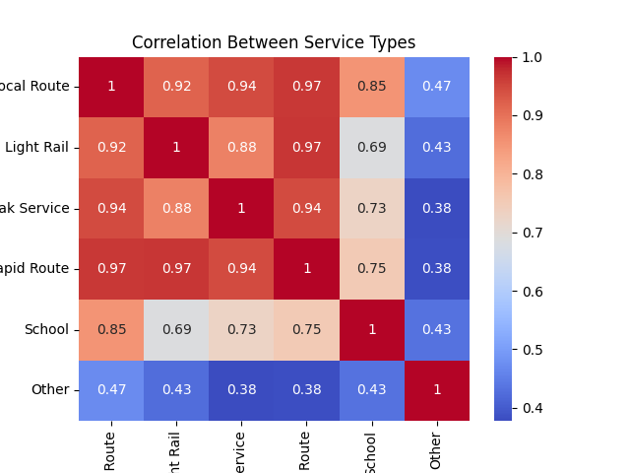

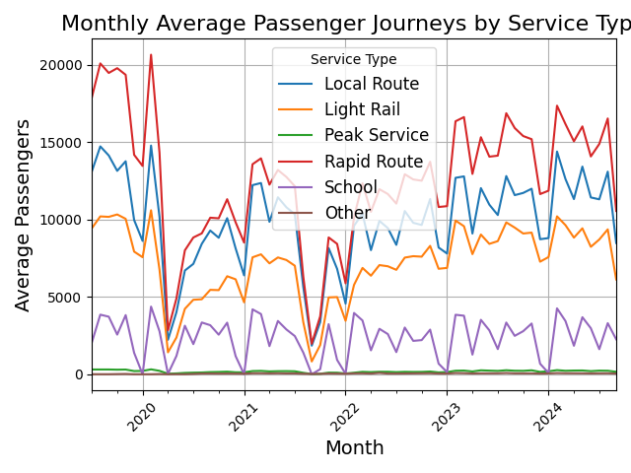

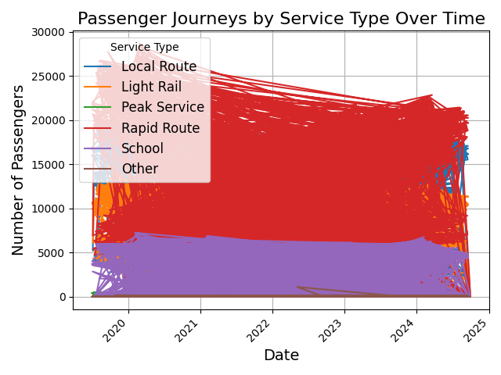

Rapid Route has to be given higher priority.